Table S... (Alternative to Table 3 in main text) Results of linear models showing the response of linear selection gradients for first flowering date of Lathyrus vernus in 22 study years to (A) spring temperature, measured as mean daily temperature in April and May, (B) position of the flowering season, measured as the date when 10% of the plants had started flowering (10% FFD), the mean first flowering date (Mean FFD) and the day the when 90% of the plants had started flowering (10% FFD), and (C) duration of the flowering season, measured as the number of days between the date when 10% of the plants had started flowering and the date when 90% of the plants had started flowering (N days 90-10% FFD).
Predictor variable | Estimate | Std. error | t | Adj. R²
A) Spring temperature
Mean daily temperature April-May | -0.029 | 0.050 | -0.59 | -0.032
B) Position of the flowering season
10% FFD | 0.004 | 0.007 | 0.59 | -0.032
Mean FFD | 0.006 | 0.008 | 0.75 | -0.021
90% FFD | 0.008 | 0.009 | 0.87 | -0.011
C) Duration of the flowering season
N days 90-10% FFD | 0.003 | 0.013 | 0.24 | -0.047
***P < 0.001; **P < 0.01; *P < 0.05
Figure S1: Linear (A) and quadratic (B) phenotypic selection differentials and standard errors for first flowering date (black) and number of flowers (grey) in Lathyrus vernus on 22 study years. Circles represent the estimates (filled circles are significant estimates at α = 0.05) and bars represent the standard errors.
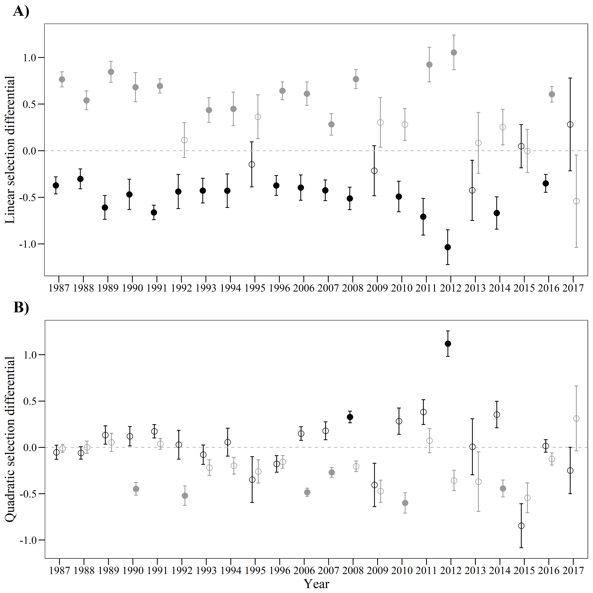
Figure S1 (alternative 1): Relationships among relative number of intact seeds and standardized first flowering date (calculated as the number of days from the vernal equinox) and number of flowers in Lathyrus vernus on 22 study years (represented with different colors). Linear (A) and quadratic (B) model fit lines are shown. The slopes of the lines represent the phenotypic selection differentials.
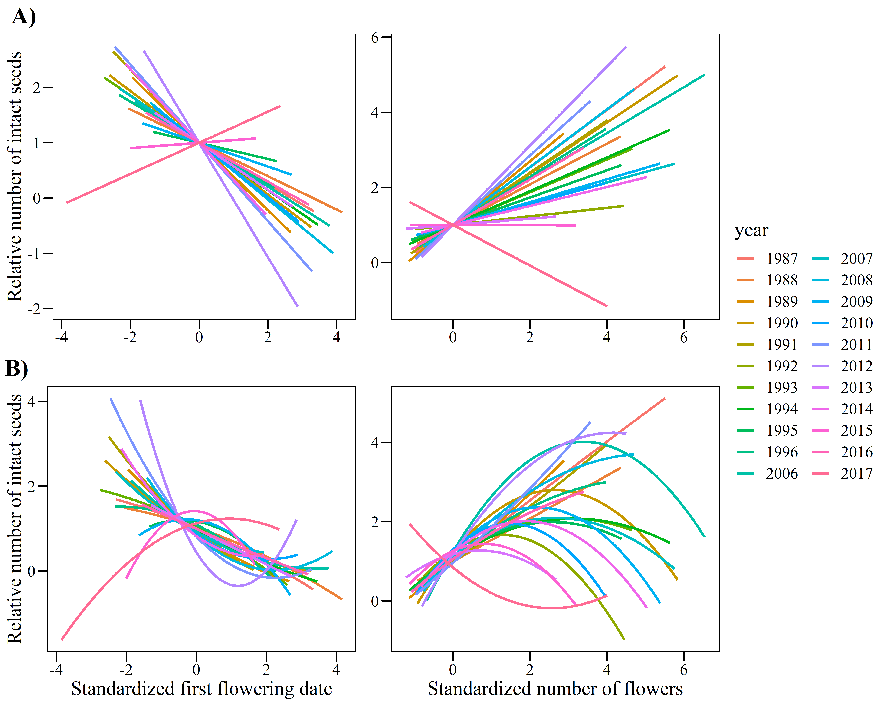
Figure S1 (alternative 2): (A) Relationships among relative number of intact seeds and standardized first flowering date (calculated as the number of days from the vernal equinox) in Lathyrus vernus on 22 study years. Linear (black) and quadratic (blue) model fit lines are shown with their standard errors. The slopes of the lines represent the phenotypic selection differentials.
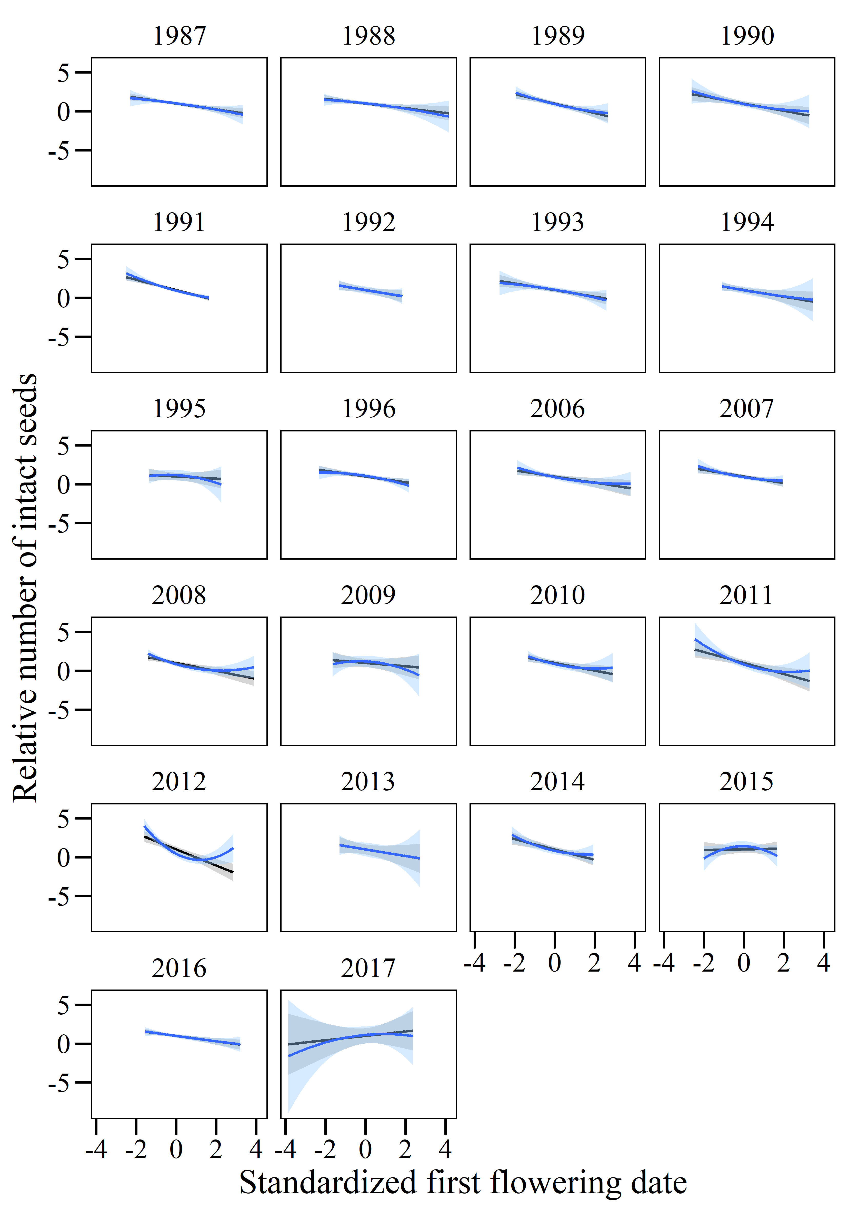
(B) Relationships among relative number of intact seeds and standardized number of flowers in Lathyrus vernus on 22 study years. Linear (black) and quadratic (blue) model fit lines are shown with their standard errors. The slopes of the lines represent the phenotypic selection differentials.
